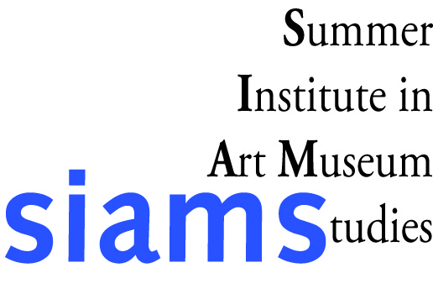
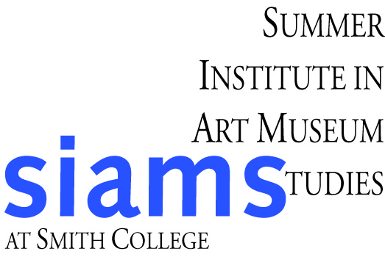
Summer Institute in Art Museum Studies

Brown SIAMS Fellowship

Please submit with your complete application. Brown SIAMS Fellowship applicants must also submit the financial aid application.

The Brown SIAMS Fellowship (BSF) provides one student with: full SIAMS tuition, a four-week, paid work experience at the Smith College Museum of Art, and room and board at Smith College. The BSF is designed to increase the diversity of students gaining exposure to the museum field and to strengthen the museum field in return.

Name of Applicant:

Please provide a brief statement, in no more than 300 words, that describes how SIAMS and the work experience would impact your educational and career goals, and how your experiences could contribute to the study of museums at SIAMS this summer.

Please mail or submit electronically your complete application materials so that they arrive at Smith by March 9, 2012 to:
Summer Institute in Art Museum Studies, Smith College Museum of Art, Elm Street at Bedford Terrace, Northampton, MA 01063
Or to: siams@smith.edu

